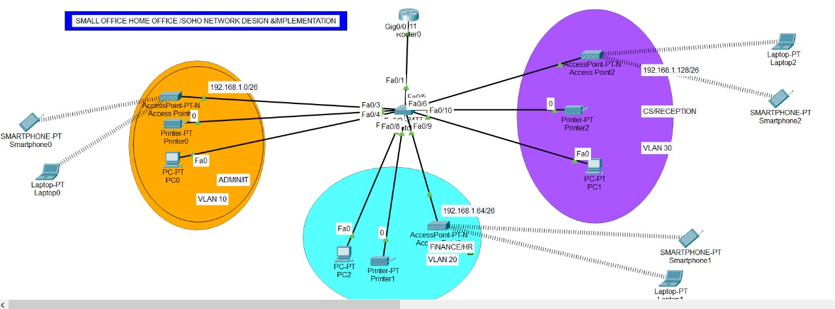
SMALL OFFICE HOME OFFICE (SOHO) NETWORK DESIGN & IMPLEMENTATION

1. ABSTRACT

This project presents the design and implementation of a Small Office Home Office (SOHO) network using Cisco networking devices. The network is designed for a new branch of XYZ Company located near Bonalbo village, Australia. The solution uses VLANs, Router-on-a-Stick architecture, DHCP, and wireless access to provide secure, scalable, and efficient communication between departments. The network operates independently from the headquarters and fulfills all functional requirements with minimal hardware.

---

2. INTRODUCTION

XYZ Company is a fast-growing organization in Eastern Australia with more than two million customers worldwide. To support business expansion, the company plans to open a new branch office near Bonalbo village.

The branch network must function independently from the headquarters network while ensuring efficient communication among departments. As a network engineer, the responsibility is to design and implement a cost-effective and scalable SOHO network using Cisco devices.

---

3. PROBLEM STATEMENT

Design and implement a SOHO network that:

Uses one router and one switch

Supports three departments

Implements VLAN-based segmentation

Provides wireless and wired connectivity

Assigns IPv4 addresses automatically

Allows communication between all departments

---

4. PROJECT OBJECTIVES

The objectives of this project are:

To design a SOHO network using Cisco devices

To implement VLAN-based network segmentation

To configure Router-on-a-Stick for inter-VLAN routing

To enable wireless connectivity for all departments

To configure DHCP for automatic IP addressing

To allow seamless inter-department communication

---

5. NETWORK REQUIREMENTS

The following requirements were provided:

1. One router and one switch (Cisco products)

2. Three departments:

Admin / IT

Finance / HR

Customer Service / Reception

3. Separate VLAN for each department

4. Wireless network for each department

5. Automatic IPv4 addressing using DHCP

6. Communication between all departments

---

6. NETWORK TOPOLOGY

The network uses a Router-on-a-Stick topology, where:

A single router interface is divided into multiple sub-interfaces

The switch connects all end devices

VLANs logically separate departments

The router performs inter-VLAN routing

Each department includes:

Personal Computers

Printers

Wireless Access Points

Laptops and smartphones

---

7. VLAN DESIGN

VLAN ID Department VLAN Name

10 Admin / IT ADMIN_IT
20 Finance / HR FIN_HR
30 Customer Service / Reception CS_RECEPTION

8.SUBNETTING

1. Introduction to Subnetting

Subnetting is the process of dividing a single large network into multiple smaller networks called subnets. In this project, subnetting is used to:

Separate departments logically

Improve network performance

Enhance security

Support VLAN implementation

The ISP has provided a base network of 192.168.1.0/24, which must be divided to support three departments.

---

2. Given Network Details

Base Network: 192.168.1.0/24

Subnet Mask: 255.255.255.0

Total IP Addresses: 256

Departments Required: 3

Each department requires its own subnet.

---

3. Subnet Calculation

To create at least 3 subnets, we borrow 2 bits from the host portion.

Calculation

Original subnet: /24

Borrowed bits: 2

New subnet mask: /26

New Subnet Mask

/26 = 255.255.255.192

Number of Subnets

2² = 4 subnets

Hosts per Subnet

2⁶ − 2 = 62 usable hosts

This is sufficient for each department.

---

4. Subnet Breakdown

Subnet 1 – VLAN 10 (Admin / IT)

Network Address: 192.168.1.0

Subnet Mask: 255.255.255.192 (/26)

First Usable IP: 192.168.1.1

Last Usable IP: 192.168.1.62

Broadcast Address: 192.168.1.63

Default Gateway: 192.168.1.1

---

Subnet 2 – VLAN 20 (Finance / HR)

Network Address: 192.168.1.64

Subnet Mask: 255.255.255.192 (/26)

First Usable IP: 192.168.1.65

Last Usable IP: 192.168.1.126

Broadcast Address: 192.168.1.127

Default Gateway: 192.168.1.65

---

Subnet 3 – VLAN 30 (Customer Service / Reception)

Network Address: 192.168.1.128

Subnet Mask: 255.255.255.192 (/26)

First Usable IP: 192.168.1.129

Last Usable IP: 192.168.1.190

Broadcast Address: 192.168.1.191

Default Gateway: 192.168.1.129

---

Subnet 4 – Reserved

Network Address: 192.168.1.192/26

Reserved for future expansion

---

5. Subnetting Summary Table

VLAN Department Network Usable Range Broadcast

10 Admin / IT 192.168.1.0/26 192.168.1.1 – 62 192.168.1.63
20 Finance / HR 192.168.1.64/26 192.168.1.65 – 126 192.168.1.127
30 Customer Service 192.168.1.128/26 192.168.1.129 – 190 192.168.1.191

---

6. Why /26 Subnet Mask Was Chosen

Supports up to 62 hosts per department

Efficient use of IP addresses

Easy VLAN-to-subnet mapping

Allows future scalability

Best suited for SOHO networks

---

7. Conclusion

Subnetting the base network 192.168.1.0/24 into /26 subnets successfully meets the requirements of the SOHO network. Each department is assigned a unique subnet, enabling efficient VLAN implementation, automatic IP assignment via DHCP, and seamless inter-department communication.

---

8. IP ADDRESSING SCHEME

Base Network: 192.168.1.0/24

VLAN Network Address Subnet Mask Default Gateway

10 192.168.1.0/26 255.255.255.192 192.168.1.1
20 192.168.1.64/26 255.255.255.192 192.168.1.65
30 192.168.1.128/26 255.255.255.192 192.168.1.129

---

9. HARDWARE & SOFTWARE REQUIREMENTS

Hardware

Cisco Router

Cisco Switch

PCs

Printers

Wireless Access Points

Software

Cisco Packet Tracer

---

10. IMPLEMENTATION DETAILS

10.1 Router Configuration

Router interface configured as trunk

Sub-interfaces created for VLANs

IEEE 802.1Q encapsulation used

Router acts as default gateway

DHCP configured for all VLANs

10.2 Switch Configuration

VLANs created

Router-facing port configured as trunk

End-device ports configured as access ports

10.3 Wireless Configuration

Separate SSID for each department

Wireless devices connected through Access Points

IP addresses assigned via DHCP

---

11. DHCP IMPLEMENTATION

DHCP is implemented to:

Automatically assign IP addresses

Reduce manual configuration

Improve scalability and manageability

Each VLAN has a separate DHCP pool.

---

12. INTER-VLAN COMMUNICATION

Inter-VLAN routing is enabled using Router-on-a-Stick architecture. This allows:

Communication between departments

Access to shared resources such as printers

Centralized traffic management through the router

---

13. TESTING & VERIFICATION

The following tests were performed:

Test Result

Same VLAN communication Successful
Inter-VLAN communication Successful
Wireless connectivity Successful
DHCP IP assignment Successful
Printer access Successful

---

14. RESULTS & DISCUSSION

The SOHO network was successfully implemented according to the given requirements. VLAN segmentation improved network organization, while Router-on-a-Stick enabled efficient inter-department communication. DHCP simplified IP management, and wireless access enhanced mobility for users.

---

15. CONCLUSION

This project successfully demonstrates the design and implementation of a SOHO network using VLANs, DHCP, wireless networking, and Router-on-a-Stick architecture. The network meets all business requirements while using minimal hardware. The solution is scalable, cost-effective, and suitable for small branch offices.

---

16. FUTURE SCOPE

Implementation of ACLs for enhanced security

Internet connectivity and NAT configuration

Network monitoring and logging

Redundancy and backup links

---

17. REFERENCES

1. Cisco Networking Academy

2. Cisco Packet Tracer Documentation

3. Computer Networking – Kurose & Ross

CONFIGURATION ON SOHO
1. ROUTER CONFIGURATION (Router-on-a-Stick)

Enable Router & Interface

enable
configure terminal
hostname Router0

interface g0/0
no shutdown

---

1.1 Sub-Interface Configuration (Inter-VLAN Routing)

VLAN 10 – ADMIN / IT

interface g0/0.10
encapsulation dot1Q 10
ip address 192.168.1.1 255.255.255.192

VLAN 20 – FINANCE / HR

interface g0/0.20
encapsulation dot1Q 20
ip address 192.168.1.65 255.255.255.192

VLAN 30 – CUSTOMER SERVICE / RECEPTION

interface g0/0.30
encapsulation dot1Q 30
ip address 192.168.1.129 255.255.255.192

---

1.2 DHCP Configuration (Automatic IP Addressing)

Exclude Gateway Addresses

ip dhcp excluded-address 192.168.1.1 192.168.1.10
ip dhcp excluded-address 192.168.1.65 192.168.1.70
ip dhcp excluded-address 192.168.1.129 192.168.1.135

DHCP Pool – VLAN 10

ip dhcp pool ADMIN_IT
network 192.168.1.0 255.255.255.192
default-router 192.168.1.1
dns-server 8.8.8.8

DHCP Pool – VLAN 20

ip dhcp pool FIN_HR
network 192.168.1.64 255.255.255.192
default-router 192.168.1.65
dns-server 8.8.8.8

DHCP Pool – VLAN 30

ip dhcp pool CS_RECEPTION
network 192.168.1.128 255.255.255.192
default-router 192.168.1.129
dns-server 8.8.8.8

end
write memory

---

2. SWITCH CONFIGURATION

Enable Switch

enable
configure terminal
hostname Switch0

---

2.1 VLAN Creation

vlan 10
name ADMIN_IT

vlan 20
name FIN_HR

vlan 30
name CS_RECEPTION

---

2.2 Trunk Port (Switch → Router)

interface fa0/1
switchport mode trunk

---

2.3 Access Ports Assignment

VLAN 10 – Admin / IT

interface range fa0/2 - 4
switchport mode access
switchport access vlan 10

VLAN 20 – Finance / HR

interface range fa0/5 - 7
switchport mode access
switchport access vlan 20

VLAN 30 – Customer Service

interface range fa0/8 - 10
switchport mode access
switchport access vlan 30

end
write memory

---

3. ACCESS POINT CONFIGURATION (Packet Tracer)

Admin / IT AP

SSID: Admin_WiFi

IP Assignment: DHCP

Switch Port VLAN: 10

Finance / HR AP

SSID: Finance_WiFi

IP Assignment: DHCP

Switch Port VLAN: 20

Customer Service AP

SSID: CS_WiFi

IP Assignment: DHCP

Switch Port VLAN: 30

---

4. END DEVICE CONFIGURATION

For PCs, Laptops, Smartphones:

IP Configuration → DHCP

They will automatically receive:

IP Address

Subnet Mask

Default Gateway

DNS Server

---

5. VERIFICATION COMMANDS

On Router

show ip interface brief
show ip dhcp binding

On Switch

show vlan brief
show interfaces trunk

Testing

Ping between departments → ✅ SUCCESS

Wireless to wired → ✅ SUCCESS

Printer access → ✅ SUCCESS

---

6. FINAL RESULT

✔ VLANs implemented
✔ Wireless enabled per department
✔ Automatic IP addressing
✔ Inter-VLAN communication enabled
✔ Matches assignment requirements

Ye project kaise dikhaya jata hai us format me likhi jaisa project ka format hota hai

